**Lab 6: Functions**

**Question1:**

Write the following function to display an integer in reverse order:

**def** reverse(number): For example, **reverse(3456)** displays **6543**. Write a test program that prompts  the user to enter an integer and displays its reversal.

**Question2:**

Write a function that prints characters using the following header:

**def** printChars(ch1, ch2, numberPerLine):

This function prints the characters between **ch1** and **ch2** with the specified numbers per line.

Write a test program that prints ten characters per line from **1** to **Z**.

**Question 3:**

Write a function that displays an *n*-by-*n* matrix using the following header:   **def** printMatrix(n): Each element is 0 or 1, which is generated randomly.

Write a test program that  prompts the user to enter **n** and displays an *n*-by-*n* matrix. Here is a sample run:

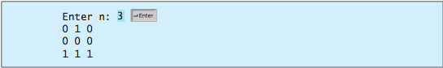

**Question 4:**

Write a function with the following header to format the integer with the specified width.

**def** format(number, width):

The function returns a string for the number with prefix **0**s. The size of the string is the width.

For example, **format(34, 4)** returns **"0034"** and **format(34, 5)** returns **"00034"**. If the number is longer than the width, the function returns the string representation for the number. For example, **format(34, 1)** returns **"34"**.

Write a test program that prompts the user to enter a number and its width and dis- plays a string returned from invoking **format(number, width)**. Here is a sample run:

